Final Project Report

Mushroom Fungi classification using Machine Learning



Project Supervisor

Hina Ishaq

Submitted By

F220178C0F

Muhammad Haseeb Mustafa Bc190402477

Software Projects & Research Section,
Department of Computer Sciences,
Virtual University of Pakistan


CERTIFICATE

This is to certify that Muhammad Haseeb Mustafa (B190402477), have worked on and completed their Software Project at Software & Research Projects Section, Department of Computer Sciences, Virtual University of Pakistan in partial fulfillment of the requirement for the degree of BS in Computer Sciences under my guidance and supervision.

In our opinion, it is satisfactory and up to the mark and therefore fulfills the requirements of BS in Computer Sciences.

Supervisor / Internal Examiner

Hina Ishaq
Supervisor,
Software Projects & Research Section,
Department of Computer Sciences
Virtual University of Pakistan

___________________
(Signature)

External Examiner/Subject Specialist
<<External Supervisor Name>>

___________________
(Signature)

Accepted By:

_____________
(For office use)

EXORDIUM

In the name of Allah, the Compassionate, the Merciful.

Praise be to Allah, Lord of Creation,
The Compassionate, the Merciful,
King of Judgment-day!

You alone we worship, and to You alone we pray for help,
Guide us to the straight path

The path of those who You have favored,

Not of those who have incurred Your wrath,
Nor of those who have gone astray.

DEDICATION

This project is dedicated to the awe-inspiring world of mushroom fungi and the scientists, researchers, and enthusiasts who have devoted their lives to understanding and classifying these fascinating organisms.

To the mycologists who tirelessly explore the diverse forms, habitats, and functions of mushrooms, this dedication honors your unwavering passion and commitment. Your meticulous observations, fieldwork, and laboratory experiments have paved the way for a deeper understanding of the fungal kingdom.

To the botanists, biologists, and ecologists who recognize the critical role of fungi in our ecosystems, this dedication acknowledges your efforts to unravel the intricate relationships between mushrooms and their environment. Your dedication to conservation, preservation, and sustainable practices ensures the preservation of these invaluable organisms for future generations.

To the machine learning researchers and data scientists who have applied their expertise to the realm of mushroom fungi classification, this dedication celebrates your innovative spirit and unwavering pursuit of knowledge. Your development and application of cutting-edge algorithms and models have accelerated our ability to classify and identify mushroom species with greater accuracy and efficiency.

Finally, to the countless students, amateur mycologists, and nature enthusiasts who have found solace, inspiration, and endless curiosity in the world of mushrooms, this dedication recognizes your unwavering passion for the natural world. Your eagerness to learn, explore, and share knowledge fuels the ongoing discovery and appreciation of mushroom fungi.

May this project contribute to the collective understanding and preservation of mushroom fungi, inspiring future generations to delve into the wonders of this extraordinary kingdom.

ACKNOWLEDGEMENT

I would like to express my deepest gratitude and appreciation to all those who have contributed to the successful completion of my project on mushroom fungi classification. Without their invaluable support and guidance, this project would not have been possible.

First and foremost, I would like to extend my heartfelt thanks to my supervisor Mam Hina Ishaq, for their unwavering guidance, expertise, and continuous support throughout the duration of this project.

I am also indebted to the faculty members of Virtual university of Pakistan, whose invaluable insights and constructive feedback have significantly enriched my understanding of the subject matter. Their dedication to teaching and commitment to academic excellence have been a constant source of inspiration for me.

I would like to extend my sincere gratitude to the researchers and scientists in the field of mycology, whose seminal works and publications have served as the foundation for my research. Their pioneering efforts in mushroom fungi classification have paved the way for advancements in the field and have been instrumental in shaping my approach.

Furthermore, I would like to thank the my colleagues and friends, whose continuous encouragement, support, and collaboration have been invaluable throughout this project. Their willingness to engage in discussions, provide feedback, and share their expertise has significantly enhanced the quality of my research.

Lastly, I would like to express my deep appreciation to my family for their unwavering love, understanding, and encouragement throughout this endeavor. Their constant support has been a pillar of strength for me, enabling me to overcome challenges and pursue my research with dedication and enthusiasm.

In conclusion, I extend my heartfelt gratitude to all those who have directly or indirectly contributed to the successful completion of this project on mushroom fungi classification. Your support, guidance, and encouragement have been instrumental in shaping the outcome of this research, and I am truly grateful for your contribution.
PREFACE
Mushrooms are a diverse group of fungi that play an important role in the ecosystem. They are also a popular food source for humans, but some mushrooms can be poisonous. This project investigates the use of machine learning to classify mushrooms into edible and poisonous species.

The dataset used for this project is the Mushrooms Data Set from kaggle. This dataset contains 8124 observations of mushrooms, each with 23 features describing the physical characteristics of the mushroom. The goal of this project is to build a machine learning model that can accurately classify mushrooms into edible and poisonous species.

The project is divided into five phases:

- Data collection and preprocessing
- Feature extraction
- Model selection and training
- Model evaluations
- Conclusion
The results of this project show that machine learning can be used to classify mushrooms with high accuracy. The best performing model was a decision tree classifier and Random forest, which achieved an accuracy of 1.0% on the test set.

This project has several limitations. The first limitation is that the dataset used for this project is relatively small. This means that the results of this project may not be generalizable to all mushrooms. The second limitation is that the features used in this project are limited to the physical characteristics of the mushroom. Other features, such as the chemical composition of the mushroom, could also be used to improve the accuracy of the model.

Despite these limitations, this project shows that machine learning can be a valuable tool for classifying mushrooms. This project could be extended in several ways. First, the dataset could be expanded to include more mushrooms. Second, other features, such as the chemical composition of the mushroom, could be used to improve the accuracy of the model. Third, the model could be deployed in a mobile app or website to help people identify mushrooms in the wild.
TABLE OF CONTENTS
CHAPTER NO. 1
gathering & Analyzing info 9
1.1 Introduction 10

1.2 purpose 10

1.3 scope 10

1.4 definitions, acronyms and abbreviations 10

1.4.1 Definition 10

1.4.2. Acronyms and Abbreviations 11

1.5 Project requirements 12

1.5.1 Functional Requirements 12

1.5.2 Non-Functional Requirements 13

1.6 use cases and usage scenarios 14

1.6.1 Use Case Diagrams 14

1.6.2 Usage Scenarios 15-17

1.7 Development Methodology 18-19

1.7.1 Chosen Methodology 18-19

1.7.2 Reasons for Chosen Methodology 20
1.7.3 Work Plan (Gantt chart) 21

CHAPTER NO. 2
designing the project 22

2.1 Introduction 23

2.2 Architectural Representation (Architecture Diagram) 23-24

2.3 Dynamic Model: Sequence Diagrams 25-30

2.4 Graphical User Interfaces 31-33

2.5 Test Cases 34-35

Chapter no.3
DEvelopment 36
3.1 Development plan (Architecture Diagram) 37

References 38

Appendix 39-40

CHAPTER 1
Gathering & Analyzing Info

1.1 Introduction

The classification of mushroom fungi plays a vital role in various fields such as agriculture, ecology, and pharmaceuticals. Accurate identification of mushroom fungi species is crucial for understanding their ecological impact, determining their edibility or toxicity, and exploring their potential medicinal properties. However, manual identification of mushroom fungi species is a challenging and time-consuming task due to the vast number of species and the subtle morphological differences between them. Machine learning techniques have shown promising results in automating the classification process, enabling faster and more accurate identification of mushroom fungi species.
1.2 Purpose
The purpose of this final project report is to develop a machine learning-based classification system for mushroom fungi. The project aims to leverage the power of artificial intelligence and machine learning algorithms to automate the identification process, reducing the dependence on manual efforts and enhancing the accuracy of species classification. By developing a robust and efficient classification model, this project intends to contribute to the advancement of mycology research, facilitate ecological studies, aid in the identification of edible and toxic mushrooms, and support the exploration of potential medicinal properties
1.3 Scope

The scope of this project includes the collection and preprocessing of a comprehensive dataset comprising diverse mushroom species. The dataset will consist of relevant features such as morphological attributes, ecological information, and potentially genetic data if available. Various machine learning algorithms will be explored and compared to determine the most suitable approach for mushroom classification. The project will involve training and fine-tuning the selected algorithm using the dataset, followed by an evaluation of its performance in terms of accuracy, precision, recall, and other relevant metrics. The project will also consider the interpretability of the model's decisions to provide insights into the features that contribute most significantly to the classification process. However, it is important to note that the project does not involve any experiments or analysis related to the edibility or toxicity of mushrooms, as the focus is primarily on classification rather than safety assessments.
1.4 definitions, acronyms and abbreviations

1.4.1 Definition
- Machine Learning (ML): A subset of artificial intelligence that involves the development of algorithms and statistical models, enabling computers to learn and improve from experience without being explicitly programmed.

- Mushroom Fungi Classification: The process of categorizing different species of mushroom fungi based on their characteristic features, using machine learning techniques.

- Feature Extraction: The process of selecting relevant information or characteristics from raw data (in this case, mushroom images) to be used as input for the machine learning model.

- Data Preprocessing: The step where raw data is cleaned, transformed, and organized to prepare it for machine learning training.

- Training Dataset: A subset of the data used to teach the machine learning model and help it learn patterns and relationships.

- Testing Dataset: A separate subset of the data used to evaluate the performance and accuracy of the trained machine learning model.

- Classification Model: A machine learning algorithm that is trained to assign specific categories (mushroom species) to input data (mushroom images).

- Accuracy: A metric used to measure the performance of the classification model, representing the percentage of correctly classified samples over the total number of samples.

- Logistic Regression: Logistic regression is a binary classification algorithm that estimates the probability of an instance belonging to a particular class. It models the relationship between the input variables and the probability of the binary outcome using a logistic function.

- Decision Tree: A decision tree is a hierarchical structure that represents decisions and their possible consequences. In classification tasks, a decision tree recursively partitions the input space based on feature values to predict the class labels of the instances.

- Random Forest: Random forest is an ensemble learning method that combines multiple decision trees. Each tree is trained on a random subset of the training data, and the final prediction is determined by aggregating the predictions of all the trees.

- Support Vector Machine (SVM): SVM is a powerful algorithm for both binary and multi-class classification. It creates a hyperplane or set of hyperplanes that separate the instances of different classes with the largest margin. SVM can handle linear and non-linear classification problems through the use of different kernel functions.

- K-Nearest Neighbors (KNN): KNN is a non-parametric classification algorithm that assigns labels to instances based on the majority vote of their k nearest neighbors in the feature space. The value of k determines the number of neighbors considered.

- Naive Bayes: Naive Bayes is a probabilistic classifier based on Bayes' theorem and the assumption of independence among the features. It calculates the probability of an instance belonging to a certain class given its feature values and selects the class with the highest probability.

1.4.2. Acronyms and Abbreviations

ML: Machine Learning
LR: Logistic Regression
SVM: Support Vector Machine
RF: Random Forest
DT: Decision Tree
NB: Naïve Bayes
KNN: K-Nearest Neigbours
CSV: Comma-Separated Values

1.5 Project requirements

1.5.1 Functional Requirements:

Administrator will perform all these tasks.
- Data-Collection
- For this project, I collect data from Kaggle platform for the classification of mushrooms. Dataset contain 8124 records.
- Pre-processing
- As most of the data in the real world are incomplete containing noisy and missing values. Therefore, Ihave to apply pre-processing on the data. In pre-processing, I will normalize the dataset, remove duplicate values, and handle outliers and missing values.
- Train & Test Data
- For classification I split data into 70% training and 30% testing data sets.

- Machine learning Techniques
- I use tree classifiers/models Logistic Regression, Decision Tree, Random Forest Tree and Naïve Bayes, k-Nearest Neighbor Classifier and Support Vector Machine Classifier of machine learning techniques/algorithms.
- Confusion Matrix
- I create a confusion matrix table of each machine learning algorithms to describe the performance of a classification model.
- Accuracy Evaluation
- After all these steps I find the accuracy of all techniques and compare their accuracy.
- This project will also tell me which machine learning technique is better to classify mushrooms.

1.5.2. Non-Functional Requirements:

- Usability
The system should be easy to use. The user should check the results easily. Because one of the systems feature is timesaving. The system also should be user friendly for administrator because anyone can be administrator instead of programmers.

- Reliability
This model will be developed with machine learning techniques. With recent machine learning techniques, the data that is used is enough for reliability. The administrator can be reach and use program at any time, so maintenance should not be a big issue.

- Performance
This system is developed using machine learning algorithm that already tested and best to work so this systems have perform at their best to give maximum results.

- Supportability

The system should require Python knowledge to maintenance. If any problem acquire in train model side and deep learning methods, it requires code knowledge and deep learning background to solve.
- Speed
System should also work as fast as much the advanced system should use, it depends on the processor that how much time it takes to load the python library.

1.6 use cases and usage scenarios

1.6.1 Use Case Diagrams
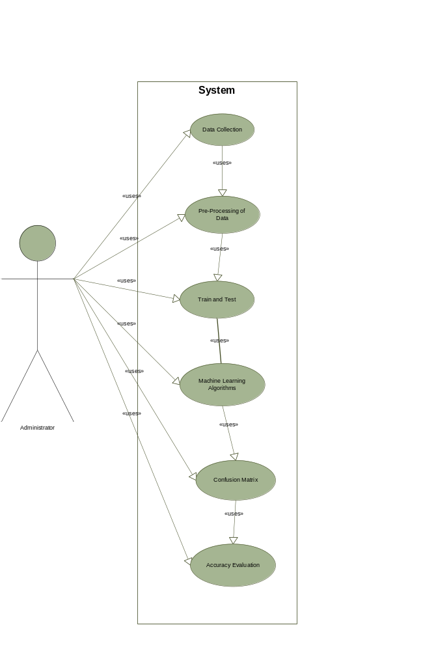

1.6.2 Usage Scenarios:

Use Case title | Data Collection
Use Case ID | UC-01
Actions | Collect Data from Kaggle
Description | - This use case is used for the collections of mushrooms data from Kaggle which is used for mushroom classifications.
Alternatives Paths | N/A
Pre Condition | - Administrator should have access to the internet to download the data form Kaggle website.
Post Condition | - Data should be downloaded in the CSV format.
Exceptions | N/A
Author | F220178C0F

Use Case title | Pre-Processing of Data
Use Case ID | UC-02
Actions | Take Data for pre processing.
Description | - This use case is used to preprocess data to remove duplicates, Null, and false values and make data accurate to avoid later error or false results.
Alternatives Paths | N/A
Pre Condition | - Administrator should download the data from Kaggle.  - Data should be in appropriate format.
Post Condition | - Data should be cleaned e.g. remove null entries, remove duplicates.
Exceptions | N/A
Author | F220178C0F

Use Case title | Train and Test
Use Case ID | UC-03
Actions | Split data in 70% train and 30%test
Description | - This use case is used to split the data with the ratio of 70% train data that we should used in train the system and 30% for the test phase.
Alternatives Paths | N/A
Pre Condition | - Data is in cleaned format and all null entries and duplicates are removed.
Post Condition | - Data should be split in the ratios of 70% train and 30% test phase.
Exceptions | N/A
Author | F220178C0F

Use Case title | Machine Learning Algorithm
Use Case ID | UC-04
Actions | Apply machine learning algorithms
Description | - This use case apply machine leaning algorithm like Logistic Regression, Decision Tree, Random Forest Tree and Naïve Bays, k-Nearest Neighbor Classifier and Support Vector Machine to classifies the mushrooms in which one is edible and which is poisonous.
Alternatives Paths | N/A
Pre Condition | - Data is splitted in given conditions.
Post Condition | - Apply all machine learning algorithms.  - Note down the results of every algorithms.
Exceptions | N/A
Author | F220178C0F

Use Case title | Confusion Matrix
Use Case ID | UC-05
Actions | To check Data Balance
Description | - This use case is used to check the data balanced between the train and test data, If data is balanced or not.
Alternatives Paths | N/A
Pre Condition | - Apply all machine learning algorithms.  - Write down all the results.
Post Condition | - Check Confusion matrix of every classifiers algorithms.  - Check the confusion matrix results and note downs.
Exceptions | N/A
Author | F220178C0F

Use Case title | Accuracy Evaluation
Use Case ID | UC-06
Actions | To compare accuracy of all algorithms
Description | - This use case is used to take results of all algorithms and compare them.
Alternatives Paths | N/A
Pre Condition | - Apply all machine learning classifiers.  - Apply confusion matrix on every classifiers.
Post Condition | - Note Down all results of machine learning classifiers algorithms.  - Check the comparable results.  - Make predictions which classifier algorithm is best for classifications according to the results.
Exceptions | N/A
Author | F220178C0F

1.7 Development Methodology

1.7.1 Chosen Methodology
VU Process Model:
After combining these two models there as another model which is called VU process model which have following characteristics:
- It is the combination of waterfall methodology and spiral methodology. It is also called hybrid approach of system development.
- VU process models a documentation driven model. Therefore it generates complete and comprehensive documentation and hence makes the maintenance task easier because the feedback of user must fulfill on each phase of the development.
- This model is heavily dependent on risk analysis and evaluation on each phase.
- Risk management and progress tracking are easy in this process model.
- It has five phases which are Software requirement Specification, secondly making Design and third and fourth is Test phase 1 and 2 and 5th is final deliverable. In requirement phase requirement is build by discussing with client.
- In the requirement phase the system goals, services and constrains are established after discussion with user.
- The planning phase is synchronized effort to find all the potential roadblocks and draft a robust plan to tackle each.
- This phase usually involves a lot of brainstorming within software development team as well as with respective client.
- It maximizes the quality of system and minimizes any risks and errors.

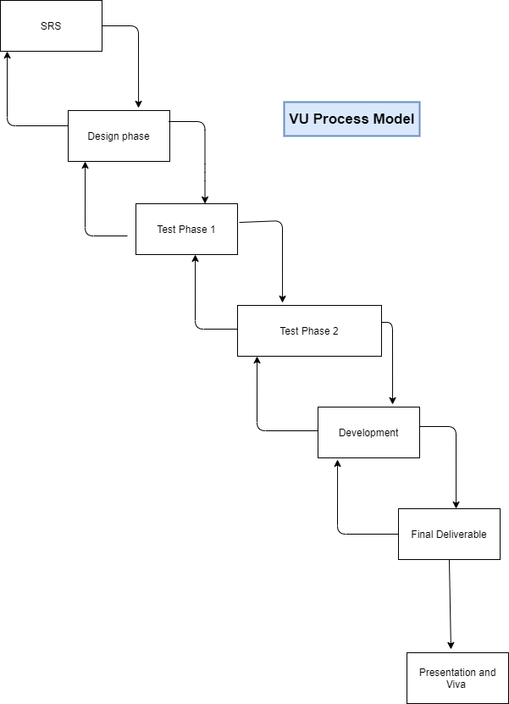

    - Reasons for Chosen Methodology

Following are the basic reasons for choosing VU Process Model for our project:
- Our project is divided into different phases which we have to complete in sequence and submit to our supervisor.
- If some mistakes are found than he suggests us to correct that mistakes and improve our project. This process will be adopted due to its spiral nature.
- When the phase is well worked-out, and also accepted by our Supervisor then we will proceed to next phase. This will be done due to the waterfall nature of the VU Process model.
- Hence both models are suppressed in single form and that will be our VU process model. It will provide error free result as each step is done in a sequence.

1.7.3 Work Plan (Gantt chart)
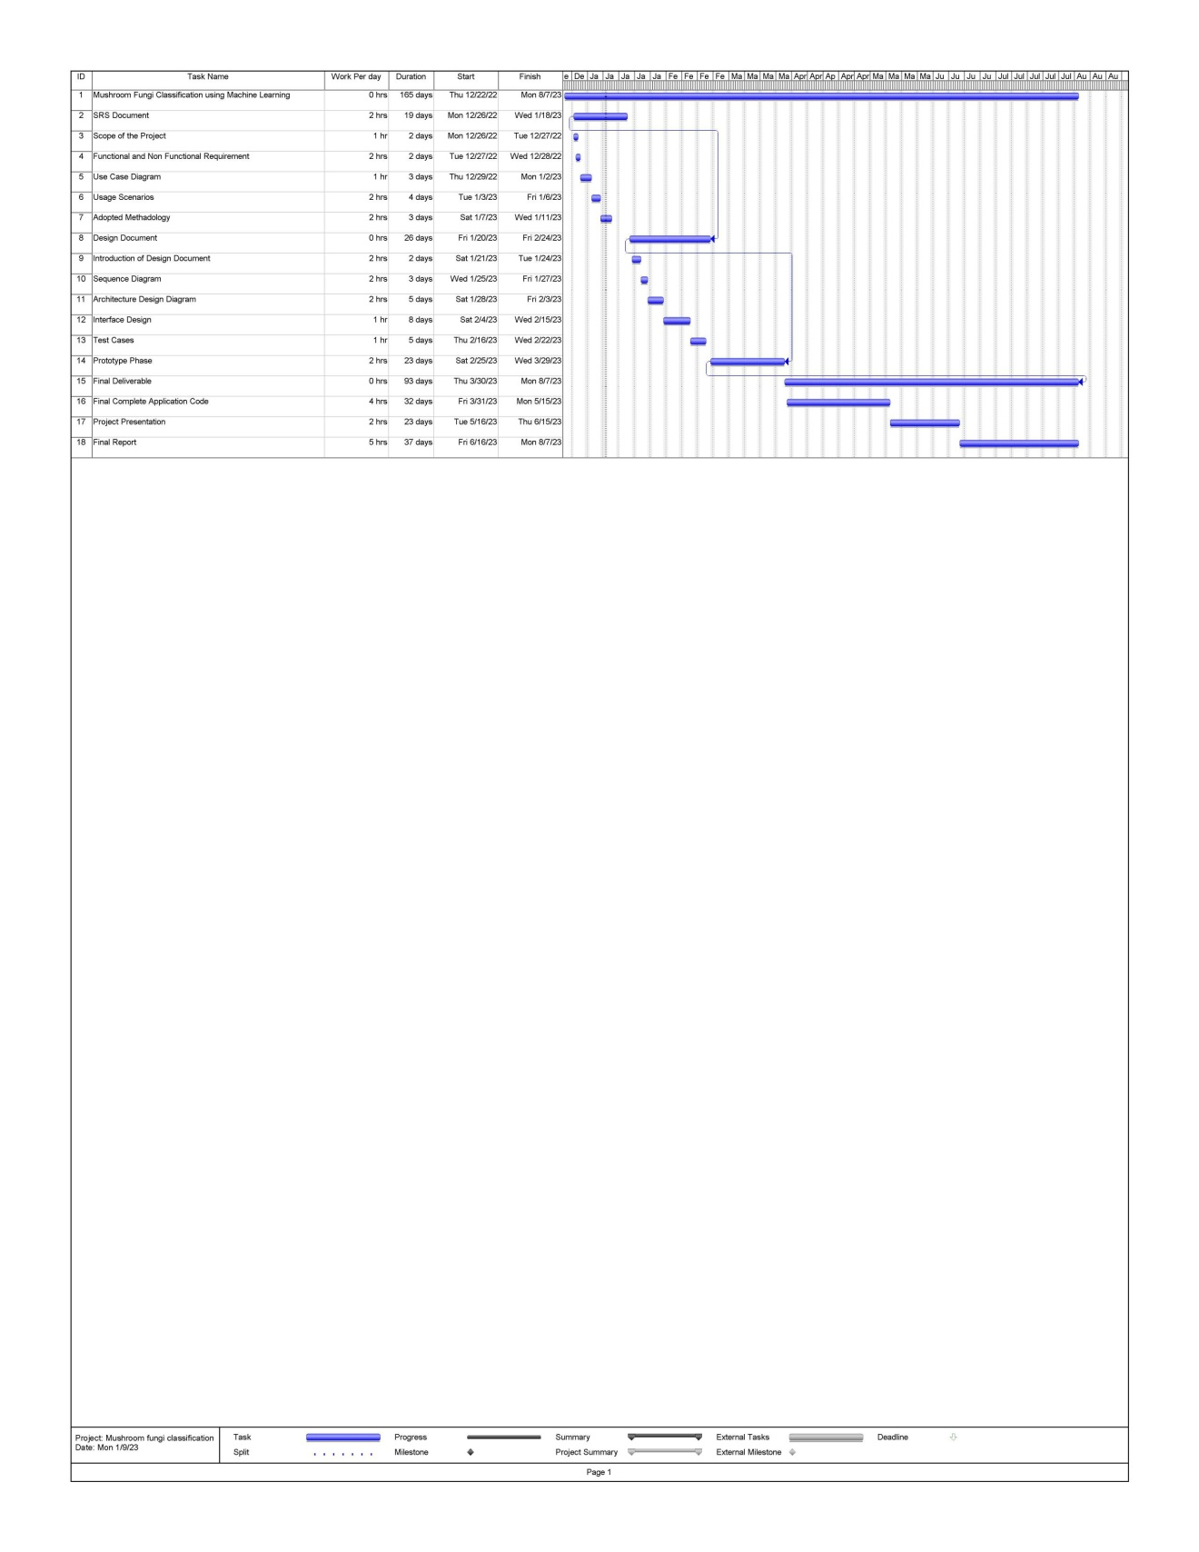

CHAPTER 2

Designing the Project

2.1 Introduction

This chapter present a system design of Mushroom fungi classification using machine learning. Design phase is provide the documentation aid in software development giving the detail of how the software should be developed. This software design chapter contains textual and graphical details of the software design which include, sequence diagram, architecture design diagram, interface design and test cases. The design activity provides a roadmap o progressively makeover the requirement into the final product through a number of stages by describing the structure of the system to be implemented. This chapter is presented in both screenshots and in textual form.

2.2 Architectural Representation (Architecture Diagram)

An architecture diagram is a visual representation of all the elements that make up part,
Of a system and how our system actually works.
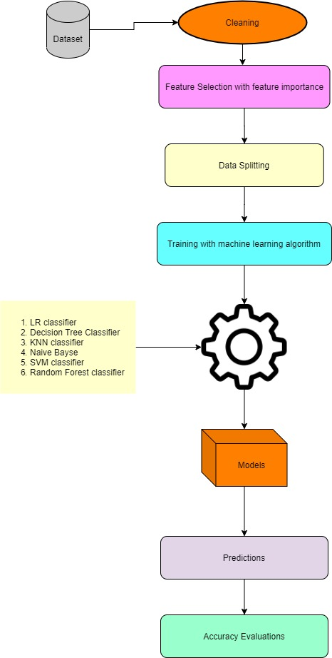

  - Dynamic Model: Sequence Diagrams

A sequence diagram is an interaction diagram that shows how software interacts with the object.
- Data:
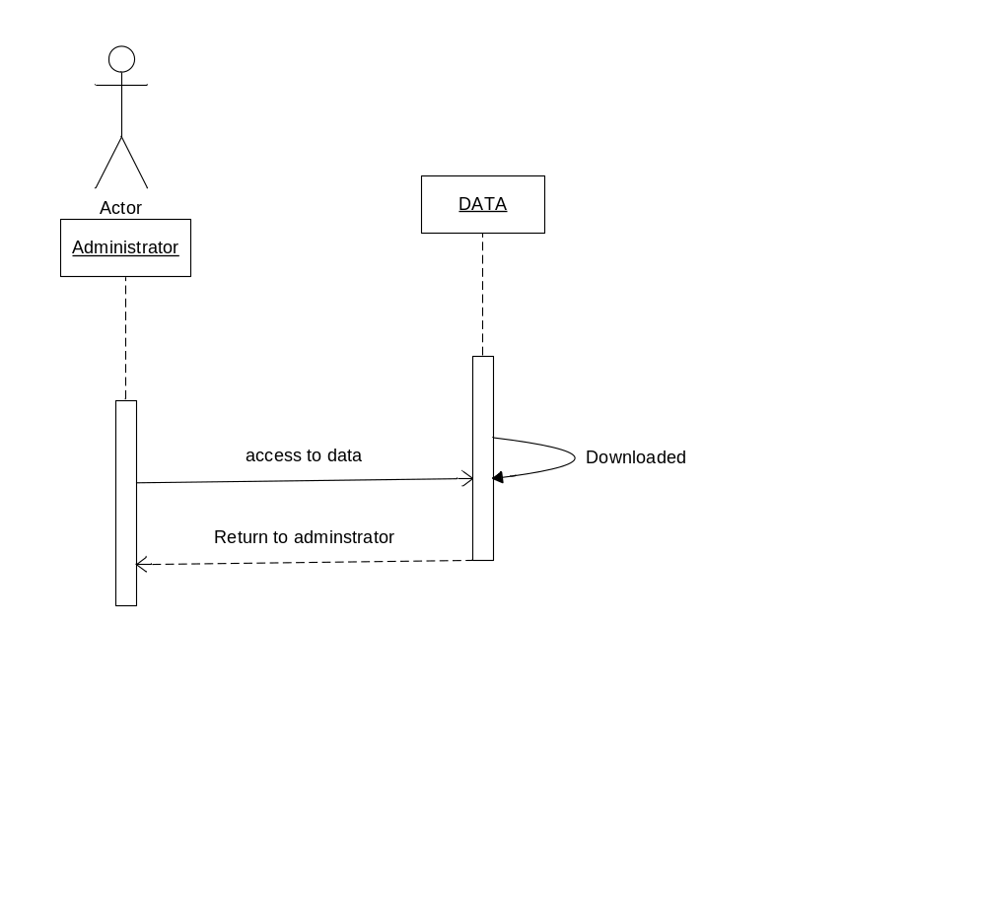

- Pre-processing of data:
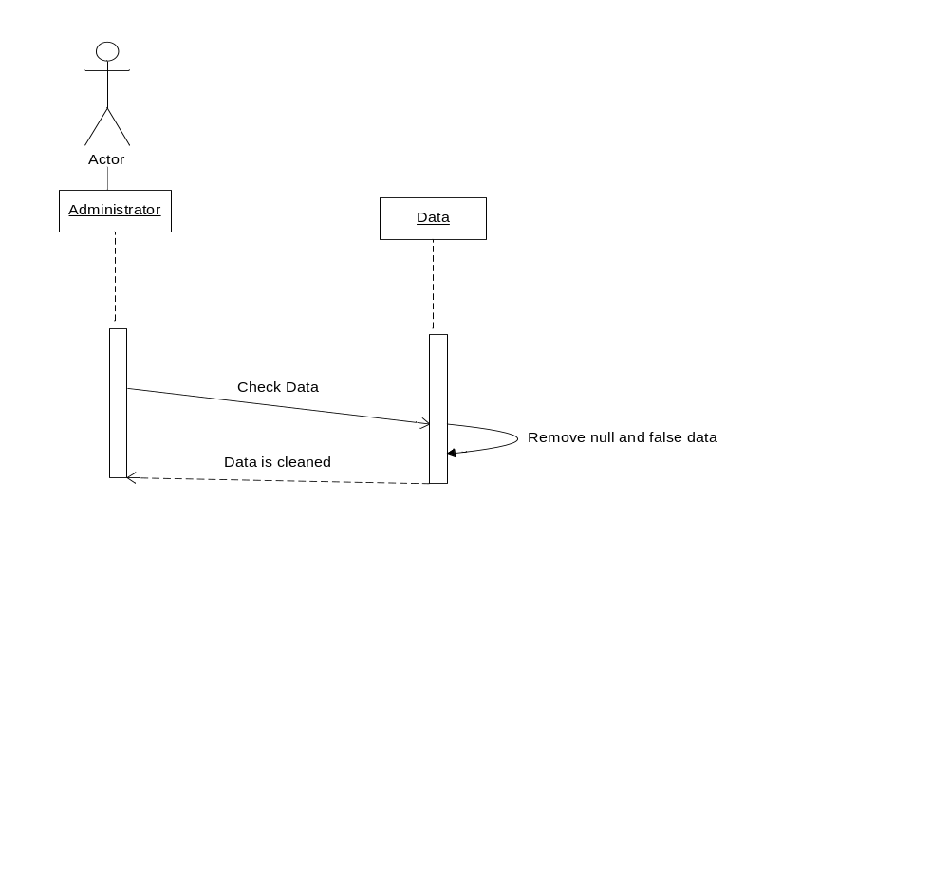

- Split and Train Data:
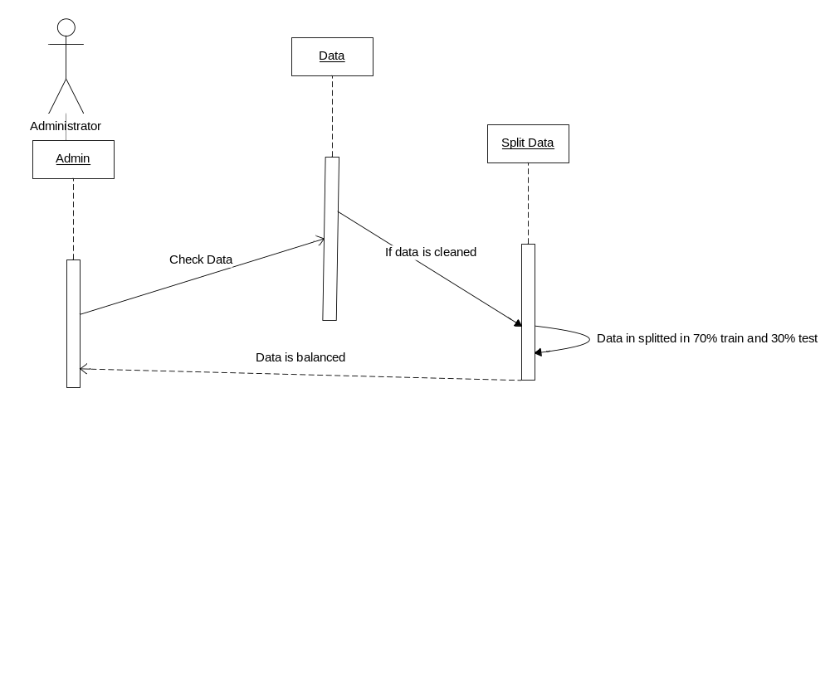

- Machine Learning Algorithm:
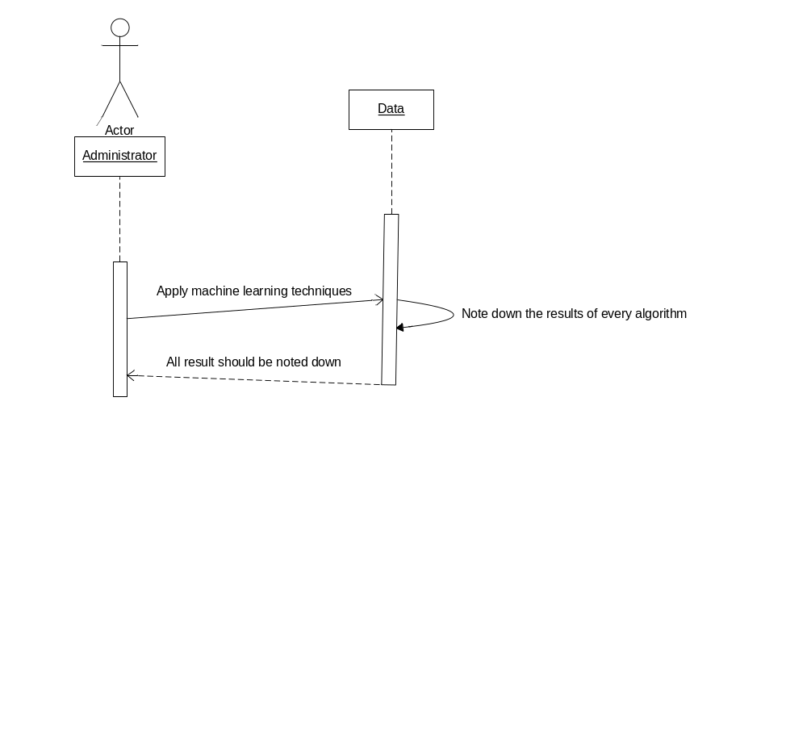

- Confusion Matrix:
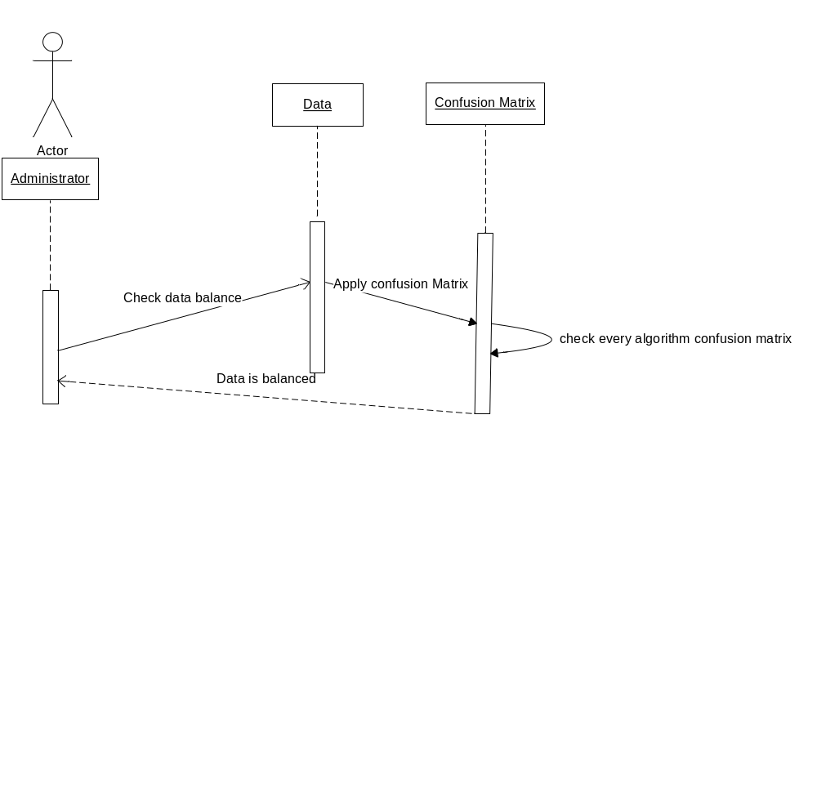

- Accuracy Evaluation:
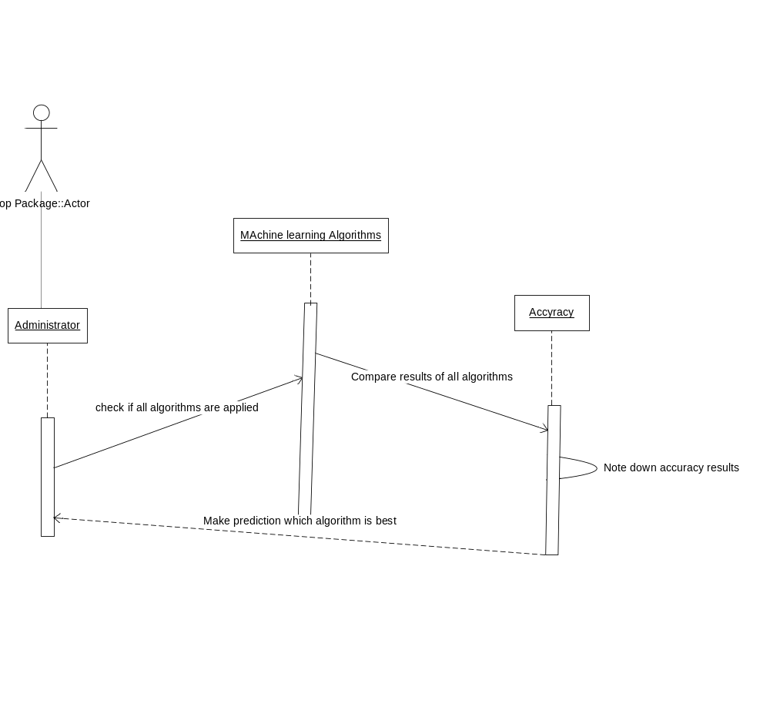

2.4 Graphical User Interfaces

Total number of edible and poisonous values:

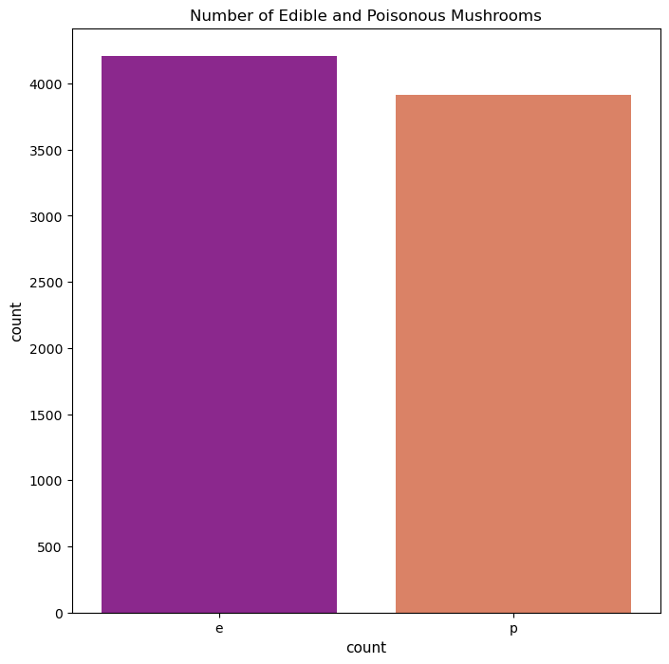

Characteristics of Data:

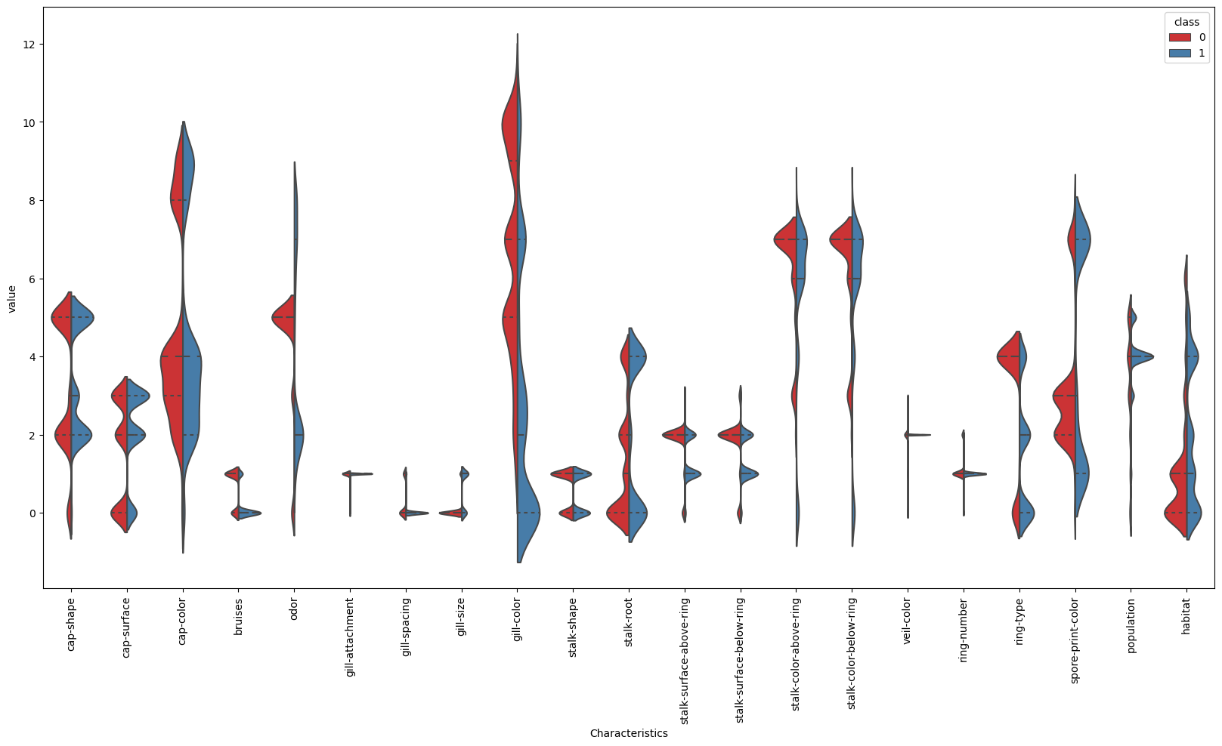

Correlation between Data Variables:

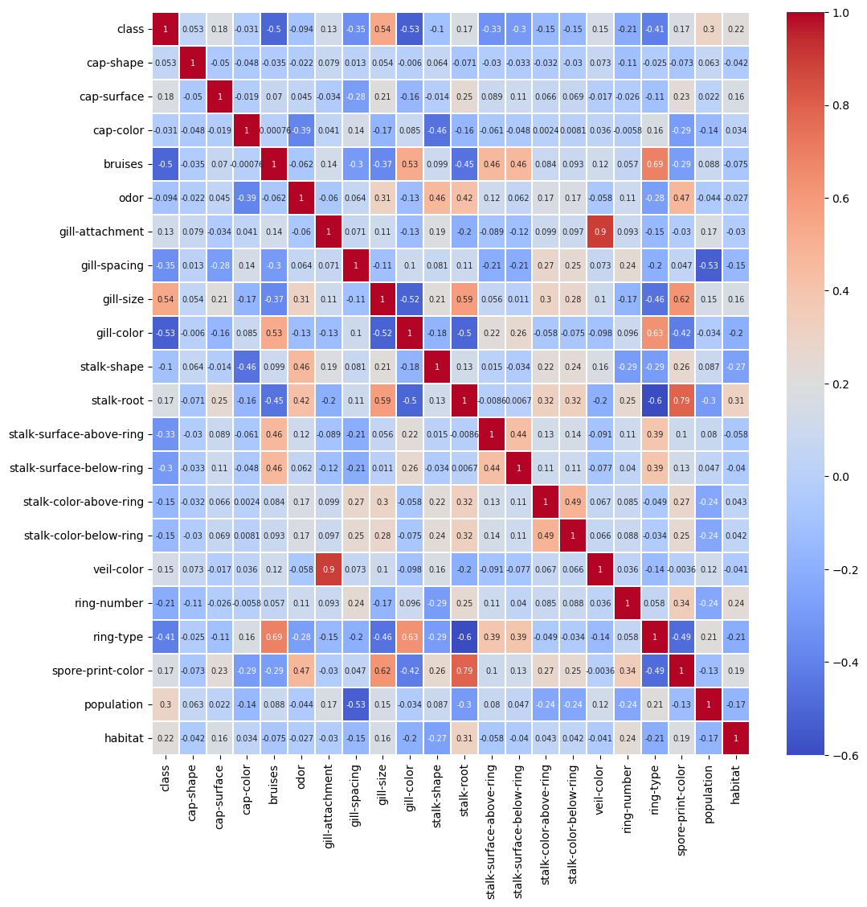

2.5 Test Cases:

Test Case # 1

Test Case Title: Testing the downloading mechanism of mushroom classification model

Test Case No. | TC-01
Test Case Name | Data
System | Mushroom Classification Model
Preconditions | Make a administrator to access the internet
Actions | Go to website to download the data.
Expected Results | Data should be downloaded.
Tested By: | Bc190402477
Result | Pass

Test Case # 2

Test Case Title: Testing the mechanism of pre-processing of mushroom classification model

Test Case No. | TC-02
Test Case Name | Pre-processing of Data
System | Mushroom Classification Model
Preconditions | Make an administrator should download the data in required format.
Actions | Open the data.
Expected Results | Remove null and false data from the dataset.
Tested By: | Bc190402477
Result | Pass

Test Case # 3

Test Case Title: Testing the mechanism of Train and Test of mushroom classification model

Test Case No. | TC-03
Test Case Name | Train and Test
System | Mushroom Classification Model
Preconditions | Make administrator open the data.
Actions | Split data in 70% for train model and 30% for test phase.
Expected Results | Data should be splitted successfully.
Tested By: | Bc190402477
Result | Pass

Test Case #4

Test Case Title: Testing the mechanism of applying machine learning algorithms of mushroom classification model

Test Case No. | TC-04
Test Case Name | Machine Learning algorithms
System | Mushroom Classification Model
Preconditions | Data should be splitted in required percentage.
Actions | Apply all machine learning algorithms.
Expected Results | All algorithms should be applied and result should be noted down.
Tested By: | Bc190402477
Result | Pass
Test Case #5
Test Case Title: Testing the mechanism of Confusion Matrix of mushroom
Classification model
Test Case No. | TC-05
Test Case Name | Confusion Matrix
System | Mushroom Classification Model
Preconditions | All algorithms properly applied.
Actions | Apply confusion matrix on every algorithm to check data is balanced or not.
Expected Results | Check results and note down.
Tested By: | Bc190402477
Result | Pass
Test Case #6
Test Case Title: Testing the mechanism of Accuracy Evaluation of mushroom classification model
Test Case No. | TC-06
Test Case Name | Accuracy Evaluation
System | Mushroom Classification Model
Preconditions | Apply all algorithms on data and confusion matrix on every classifier algorithms.
Actions | Compare the results of all classifier algorithms.
Expected Results | All results are right.
Tested By: | Bc190402477
Result | Pass

CHAPTER 3
Development

3.1 Development plan (Architecture Diagram)

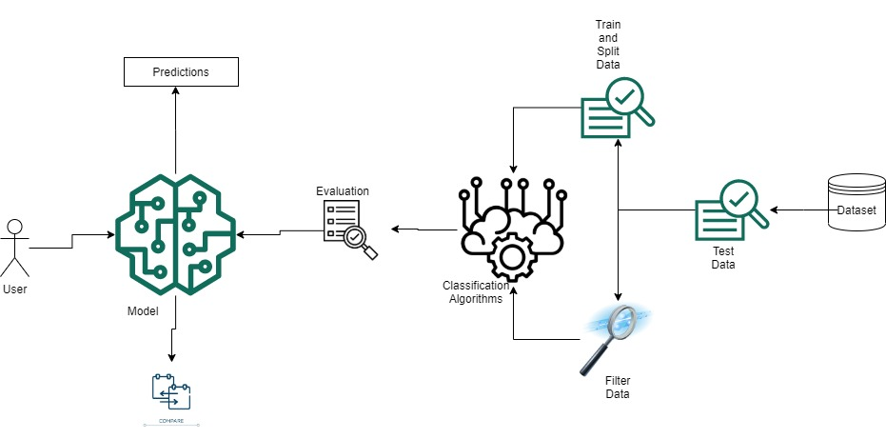
REFERENCES
LINKS:

https://towardsdatascience.com/machine-learning-an-introduction-23b84d51e6d0
https://towardsdatascience.com/top-10-algorithms-for-machine-learning-beginners-149374935f3c
https://towardsdatascience.com/10-machine-learning-methods-that-every-data-scientist-should-know-3cc96e0eeee9
https://www.tutorialspoint.com/logistic_regression_in_python/logistic_regression_in_python_tutorial.pdf
https://www.geeksforgeeks.org/ml-logistic-regression-using-python/
https://www.youtube.com/watch?v=fG4e4TUrJ3E
https://www.youtube.com/watch?v=7eh4d6sabA0
https://www.youtube.com/playlist?list=PLfoPJyH8_TpXkcJnuj8CF18-CbXPjw-ny
https://towardsdatascience.com/visualizing-decision-trees-with-python-scikit-learn-graphviz-matplotlib-1c50b4aa68dc

Sequence diagram:

https://www.lucidchart.com/pages/uml-sequence-diagram

APPENDIX

Appendix A: Mushroom Data Set

The mushroom data set used in this project is a publicly available data set that can be found at Kaggle website. The data set contains 8124 observations of mushrooms, each of which is described by 23 features. The features include the mushroom's cap shape, color, odor, gill attachment, and stalk color. The target variable is the mushroom's toxicity, which is either edible or poisonous.

Appendix B: Machine Learning Models

Three different machine learning models were used in this project:
- LR: Logistic Regression
- SVM: Support Vector Machine
- RF: Random Forest
- DT: Decision Tree
- NB: Naïve Bayes
- KNN: K-Nearest Neighbors
Appendix C: Evaluation Metrics

The performance of the machine learning models was evaluated using the following metrics:

Accuracy: Accuracy is the percentage of mushrooms that were correctly classified by the model.
Precision: Precision is the percentage of mushrooms that were classified as poisonous that were actually poisonous.
Recall: Recall is the percentage of poisonous mushrooms that were correctly classified as poisonous.
Confusion Matrix: A confusion matrix is a matrix used for evaluating the performance of a classification model.

Appendix D: Results

The results of the machine learning models are shown in the following table:
Model | Accuracy
Logistic Regression | 0.95
Support Vector Machine | 0.98
Random Forest | 1.00
Decision Tree | 1.00
Naïve Bayes | 0.92
K-Nearest Neigbours | 0.99

As you can see, all models performed well on the mushroom data set. The decision tree and Random Forest model had the highest accuracy.

Appendix E: Conclusion

The results of this project show that machine learning can be used to effectively classify mushrooms. The models that were used in this project all performed well, and they could be used to help people identify poisonous mushrooms.

In the future, it would be interesting to try other machine learning models on the mushroom data set. It would also be interesting to collect more data about mushrooms, so that the models could be trained on a larger and more diverse data set.

